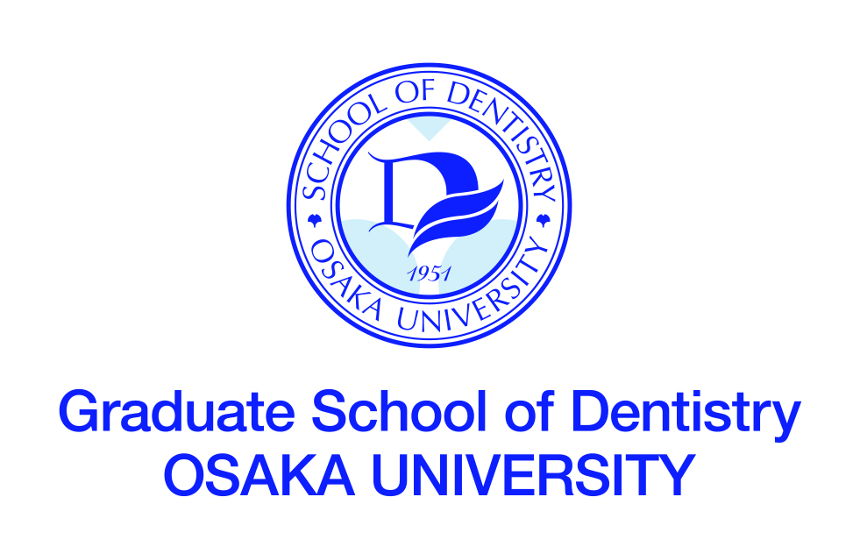

International Resident Course
in Micro-Endodontics
4-Day Course

Basic Micro-Endodontics: Introduction to the Elements of Micro-Endodontics

Department of Restorative Dentistry and Endodontology
Osaka University Dental Hospital
MAIN COURSE TITLE
Training Course in Micro-Endodontics 4-Day Course
Basic Micro-Endodontics: Introduction to the Elements of Micro-Endodontics

TRAINING NEEDS

Osaka University Dental Hospital invites dental practitioners to participate in a new clinical hands-on short course in Micro Endodontics. The aim of this course is to develop your endodontic operative skills with a focus in root canal treatments using a dental microscope. You will gain clinical experience by treating a range of challenging endodontic cases in the clinical facilities of the Osaka University Dental Hospital, under supervision of highly experienced staff, including specialists in endodontics and conservative dentistry.

The course will commence with a 3-day hands-on clinical skills component, covering all aspects of endodontics including assessment, using the endodontic microscope, isolation, access preparation, canal preparation with hand and rotary files. In the latter part of the course, participants will have opportunities of observing our clinics and discussing challenging endodontic cases.
Upon satisfactory completion of the course you will be issued with a certificate in advanced endodontic practice acknowledging the knowledge and experience gained in terms of content and number of hours

COURSE OBJECTIVES
Through the training course, participants will be expected to:
- Understand the importance and effectiveness of using a dental microscope in
endodontic treatments

- Learn a step-by-step clinical approach to Micro-Endodontics through practical
training using a dental microscope.

DEADLINE FOR APPLICATION

NUMBER OF PARTICIPANTS
5

LANGUAGE
English

REQUIREMENT FOR APPLICATION
Applicants should:
- be graduates of a university-level dental or medical school,
- be staff members (teaching and/or research) of a dental or medical school, or equivalent institution, e.g. dentists, or doctors specializing in dentistry,
- have served at university or equivalent institution for over three years,
- be at present specializing in endodontics, or hereafter intending to specialize in endodontics,
- have basic knowledge and skills of endodontics
- have sufficient command of spoken and written English,
- be in good health, both physically and mentally,
- not be serving in the military.

TRAINING INSTITUTION
Department of Restorative Dentistry and Endodontology
Osaka University Dental Hospital
1-8 Yamadaoka, Suita, Osaka 5650871 JAPAN

LOCAL COSTS and ACCOMMODATIONS
Local costs, such as accommodation, meals, and other personal expenses shall be
the responsibility of each participant.

COURSE FEE
( ) Japanese Yen

NOTES
The Faculty of Dentistry was established in 1951 as the first dental school among Japan’s national universities to promote both instructor training and research in dental science and dental health education. The Graduate School was established in 1960.
Sixty students are accepted by the Faculty of Dentistry each year. The students pursue three semesters of pre-dental general education on the Toyonaka Campus, followed by nine semester of basic and clinical dental science in the Faculty of Dentistry and the Dental Hospital on the Suita Campus (total six years).
The faculty building on the Suita Campus was completed in 1983. It has been designed to accommodate a full program of education, research and patient care, and provides laboratories as well as clinical and classroom facilities for the Dental School and the Graduate School.
At present, the Faculty of Dentistry comprises academic 22 chairs and a Research Resources Center: 8 chairs for basic dental science and 13 for clinical dental science including Oral and Maxillofacial Radiology.

TIMETABLE

Day 1
AM: Lecture ①
Basic understanding for operating a dental microscope
Historical background
Details and functions of a dental microscope for clinical use
Dental chair unit incorporating a microscope
Magnification – potential of a clinical microscope
Devices and instruments used in micro-endodontics
Tips for operating a dental microscope

AM: Practical Trainings ①
Getting started using a microscope
Adjustments
Positioning
Basic motions

Lunch

PM: Lecture ②
Principles of root preparation using a dental microscope
Clinical procedures from access cavity preparation
to enlargement of an orifice of a root canal

PM: Practical Trainings ②
Endodontic treatments of incisors and premolars.
Preparation of an access cavity
Identifying a root canal orifice
Enlargement of a root canal orifice
Shaping a root canal with NiTi files
Endodontic irrigation using an ultrasonic device
Observation of an apex

Feedback and discussion

Day 2
AM: Lecture ③
Best use of a dental microscope in treating molars with complicated configurations

AM: Practical Trainings ③
Endodontic treatments of upper molars.
Preparation of an access cavity
Identifying a root canal orifice
Shaping a root canal with NiTi files
Enlargement of a root canal orifice using an ultrasonic device
Endodontic irrigation
Observation of an apex

Lunch

PM: Practical Trainings ④
Endodontic treatments of lower molars.
Preparation of an access cavity
Identifying a root canal orifice
Shaping a root canal with NiTi files
Enlargement of a root canal orifice using an ultrasonic device
Endodontic irrigation
Observation of an apex

Feedback and discussion

Day 3
AM: Lecture ④
How best to tackle complicated cases: removing fractured instruments, repairing perforations, preparation of a C-shaped root canal, etc

AM: Practical Trainings ⑤
Tackling complicated cases
removing fractured instruments
repairing perforations
preparation of a C-shaped root canal

Lunch

PM: Lecture ⑤
Endodontic micro surgery

PM: Practical Trainings ⑥
Endodontic micro surgery: Apicoectomy of upper central incisors using a dental microscope

Feedback and discussion

Day 4
AM: Join the Clinic of Conservative Dentistry
Observing endodontic cases using a dental microscope in the clinic
Discussion on endodontic clinical cases presented by applicants

11:30～12:00 Closing Ceremony

