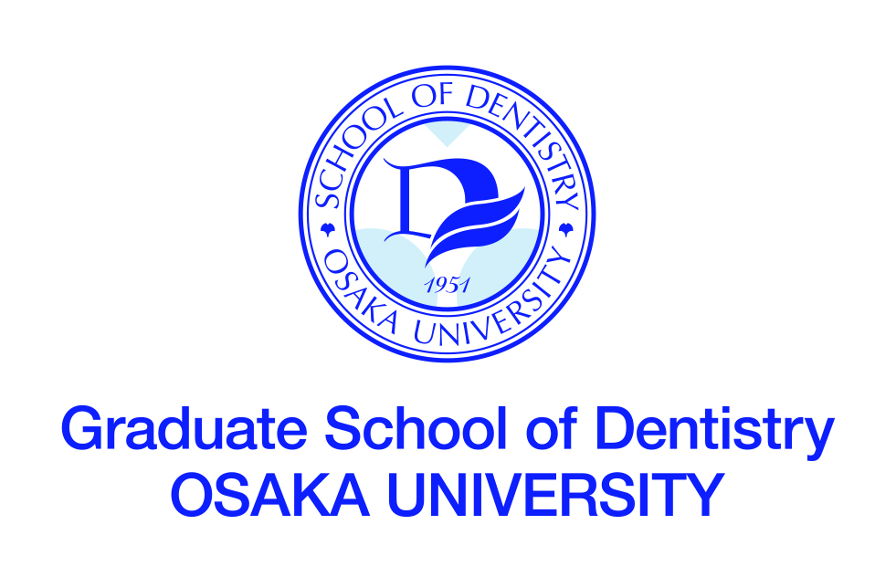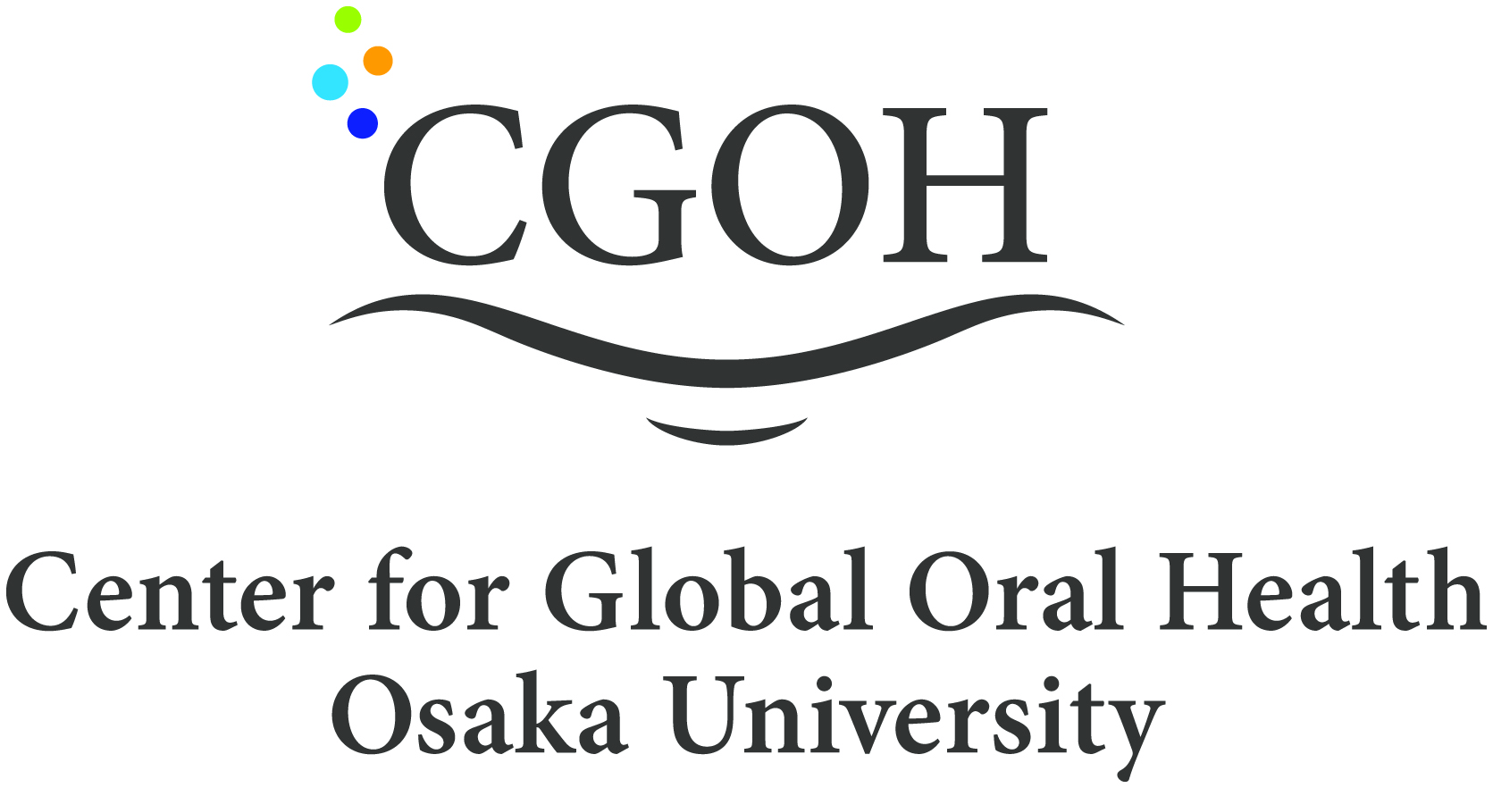

INTERNATIONAL RESIDENT COURSE IN
STANDARD CLINICAL PERIODOTOLOGY

DEPARTMENT OF PERIODONTOLOGY
OSAKA UNIVERSITY DENTAL HOSPITAL
MAIN COURSE TITLE

STANDARD CLINICAL PERIODONTOLOGY

TRAINING NEEDS
The objectives of this course is that participants understand the pathogenesis of periodontal diseases and acquire the fundamental thinking for the clinical approach for periodontal diseases with focusing on the following items,

- What is the examination? How to make a diagnosis and treatment plan for the periodontal diseases?
- How to perform the initial preparation (Periodontal treatment to eliminate the cause of disease at initial stage of therapy)?
- How to interpret the results of reevaluation of initial preparation for periodontal diseases? And, how to practice the designing of modified treatment plan and prognosis?
- How to practice the modified therapy (Periodontal surgery, occlusal reconstruction and other treatment after reevaluation of periodontal diseases)?
- What is the periodontal regenerative therapy?
- How to prevent for recurrence of periodontitis?

COURSE OBJECTIVES
Through the training course, participants will be expected to:
1) explain the diagnosis and treatment plan of periodontal diseases.

2) explain the protocols and applications for treatment of periodontal diseases.

3) explain the type of periodontal surgery and its applications.

4) practice the basic procedure for periodontal treatment including periodontal surgeries.

LANGUAGE
English

REQUIREMENT FOR APPLICATION
Applicants should:
- be graduates of a university-level dental or medical school,
- be staff members (teaching and/or research) of a dental or medical school, or equivalent institution, e.g. dentists, or doctors specializing in dentistry,
- have served at university or equivalent institution for over three years,
- be at present specializing in periodontology, or hereafter intending to specialize in periodontology
- have a sufficient command of spoken and written English,
- be in good health, both physically and mentally,
- not be serving in the military.

TRAINING INSTITUTION
Department of Periodontology
Osaka University Dental Hospital
1-8 Yamadaoka, Suita, Osaka 5650871 JAPAN

LOCAL COSTS and ACCOMMODATIONS
Local costs, such as accommodation, meals, and other personal expenses shall be
the responsibility of each participant.

COURSE FEE
340,000 Japanese Yen (It does not include national/local consumption taxes.)

NOTES
The Faculty of Dentistry was established in 1951 as the first dental school among Japan’s national universities to promote both instructor training and research in dental science and dental health education. The Graduate School was established in 1960.
Sixty students are accepted by the Faculty of Dentistry each year. The students pursue three semesters of pre-dental general education on the Toyonaka Campus, followed by nine semester of basic and clinical dental science in the Faculty of Dentistry and the Dental Hospital on the Suita Campus (total six years).
The faculty building on the Suita Campus was completed in 1983. It has been designed to accommodate a full program of education, research and patient care, and provides laboratories as well as clinical and classroom facilities for the Dental School and the Graduate School.
At present, the Faculty of Dentistry comprises academic 22 chairs and a Research Resources Center: 8 chairs for basic dental science and 13 for clinical dental science.

TIMETABLE

Day 1
AM: 9:00-11:00
Orientation

Lecture-1
Introduction of clinical periodontology
- Summary of periodontology
- Risk factors for periodontal diseases

Lecture-2
Examination and diagnosis of periodontitis
- Classification of periodontal diseases
- Endodontic-periodontal diseases

AM: 11:00-12:00

Case study, lesson 1

Lunch

PM: 13:00-17:00

Practical trainings

The simulation study using the dental medical training devices
- Examination and diagnosis of periodontitis
- TBI and scaling
- Adjustment for occlusion and temporary tooth fixation
- Scaling and root planning

Day 2
AM: 9:00-11:00
Lecture-3
Periodontal initial preparation 1
- Purposes and practice of initial preparation
- TBI and scaling

Lecture-4
Periodontal initial preparation 2
- Adjustment for occlusion and temporal tooth fixation
- Scaling・Root planning

AM: 11:00-12:00

Case study, lesson 2

Lunch

PM: 13:00-17:00

Practical trainings

The simulation study using the dental medical training devices
Reevaluation and establishment of treatment plan
- Gingival resection therapy, P-cur and ENAP
- Flap surgery (modified widman’s flap method)

Day 3
AM: 9:00-11:00
Lecture-5
Reevaluation
Purposes and practice of reevaluation
- Establishment of treatment plan for periodontal treatment

Lecture-6
Periodontal surgery
- Classification and applications for periodontal surgery
- Tissue resection therapy
- Tissue attachment therapy
- Treatment protocols for furcation problem of tooth
- Tissue regeneration therapy for periodontal tissue
- Mucogingival surgery (MGS surgery)

AM: 11:00-12:00

Case study, lesson 3

Lunch

PM: 13:00-17:00

The simulation study using the dental medical training devices
- Flap surgery (gingival flap operation)
- Hemi-section and furca-plasty
- Root amputation
- Regeneration therapy for periodontal tissue

Day 4
AM: 11:00-12:00
Lecture-7
Regeneration therapy for periodontal tissue
- Introduction of regenerative medical engineering
- Current status and future view of regeneration therapy for periodontal tissue
- Advanced periodontal therapy

Lecture-8
Maintenance of periodontitis
- Purposes and practice of ‘Maintenance’ or ‘SPT’ therapy
- Topical antibiotics therapy for periodontal disease

Systemic disease and periodontitis
- Periodontal medicine
- Treatment protocols for periodontitis with systemic disease

AM: 11:00-12:00

Case study, lesson 3

Lunch

PM: 13:00-15:00

Group study based on the case study, lesson 1- 3

15:00～15:30 Closing Ceremony

