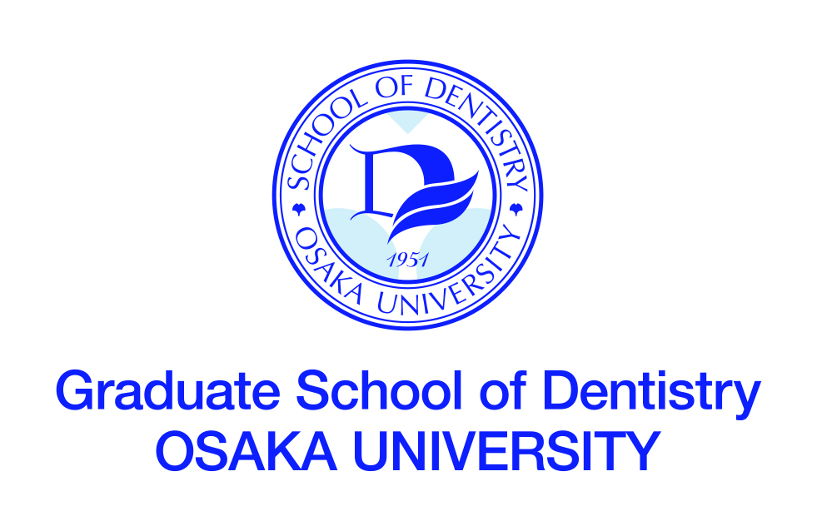

INTERNATIONAL RESIDENT COURSE IN
PEDIATRIC DENTISTRY

DEPT. of PEDIATRIC DENTISTRY
OSAKA UNIVERSITY DENTAL HOSPITAL

MAIN COURSE TITLE

Dental treatment for children and adolescents

TRAINING NEEDS
The concepts of dental treatment for children and adolescents are different from those of adults. In addition, special attention should be given for treatment of primary teeth and immature permanent teeth for the general dentists who always treat the permanent teeth.
In this course, the concepts of the dental treatment for children and adolescents are provided. Especially, important skills for treating primary and immature permanent teeth are instructed by phantom practice. Furthermore, concepts and skills for treatment planning are practiced using the real cases in our clinic.

COURSE OBJECTIVES
Through the training course, participants will be expected to:
1) understand the concepts for dental treatment for children and adolescents, especially for the topics regarding oral hygiene instruction, dental caries, traumatized teeth and occlusal guidance.

2) obtain the skills for dental treatment of children and adolescents, especially for the treatment of immature permanent teeth, fixation of traumatized teeth and restoration for anterior and posterior teeth.

3) understand the concepts and obtain the skills for the treatment planning of the cases in children and adolescents.

DEADLINE FOR APPLICATION

NUMBER OF PARTICIPANTS
4

LANGUAGE
English

REQUIREMENT FOR APPLICATION
Applicants should:
- be graduates of a university-level dental or medical school,
- be staff members (teaching and/or research) of a dental or medical school, or equivalent institution, e.g. dentists, or doctors specializing in dentistry,
- have served at university or equivalent institution for over three years,
- be at present specializing in Pediatric Dentistry, or hereafter intending to specialize in Pediatric Dentistry,
- have a sufficient command of spoken and written English,
- be in good health, both physically and mentally,
- not be serving in the military.

TRAINING INSTITUTION
Department of Pediatric Dentistry
Osaka University Dental Hospital
1-8 Yamadaoka, Suita, Osaka 5650871 JAPAN

LOCAL COSTS and ACCOMMODATIONS
Local costs, such as accommodation, meals, and other personal expenses shall be
the responsibility of each participant.

COURSE FEE
( ) Japanese Yen

NOTES
The Faculty of Dentistry was established in 1951 as the first dental school among Japan’s national universities to promote both instructor training and research in dental science and dental health education. The Graduate School was established in 1960.
Sixty students are accepted by the Faculty of Dentistry each year. The students pursue three semesters of pre-dental general education on the Toyonaka Campus, followed by nine semester of basic and clinical dental science in the Faculty of Dentistry and the Dental Hospital on the Suita Campus (total six years).
The faculty building on the Suita Campus was completed in 1983. It has been designed to accommodate a full program of education, research and patient care, and provides laboratories as well as clinical and classroom facilities for the Dental School and the Graduate School.
At present, the Faculty of Dentistry comprises academic 22 chairs and a Research Resources Center: 8 chairs for basic dental science and 13 for clinical dental science including Oral and Maxillofacial Radiology.

TIMETABLE

Day 1

9:00-10:30 Orientation and Introdcution
10:30-10:00 Lecture and Discussion 1 (Oral hygiene instruction)
Lunch
13:00-14:30 Lecture and Discussion 2 (Dental caries)
15:00-16:30 Lecture and Discussion 3 (Traumatized teeth)

Day 2

9:00-10:30 Lecture and Discussion 4 (Occlusal guidance)
10:30-12:00 Lecture for phantom practice
Lunch
13:00-14:30 Phantom practice and Discussion 1 (Immature permanent teeth)
15:00-16:30 Phantom practice and Discussion 2 (Fixation of traumatized teeth)

Day 3

9:00-10:30 Lecture for phantom practice
10:30-12:00 Phantom practice and Discussion 3 (Restoration of anterior teeth)
Lunch
13:00-14:30 Phantom practice and Discussion 4 (Restoration of posterior teeth)
15:00-16:30 Case studies and Discussion 1

Day 4

9:00-10:30 Case studies and Discussion 1
10:30-12:00 Case studies and Discussion 2
Lunch
13:00-14:30 Case studies and Discussion 3
15:00-15:30 Closing Ceremony

